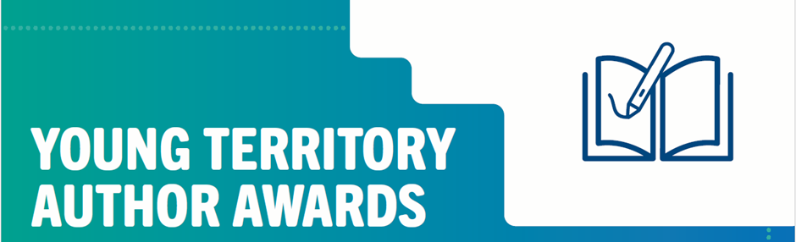
Insert date

Dear Parent,

Our class will be writing and creating a book as part of our learning this semester. We aim to enter our book in the Young Territory Author Awards.

The Young Territory Author Awards is an annual writing competition held Territory wide. The competition is open to all Territorians 18 years and under and is organised in association with other public libraries and schools throughout the Northern Territory.

Our class will enter under the Schools category. The winning school entry will receive $500 prize money.

I would like to draw your attention to this excerpt from the Terms and Conditions of entry.
- Where a school has submitted an entry, the students will only be identified by their first name and the name of the school that the student attends. Students' surnames will not be published.
- By submitting a completed entry form, an Entrant (and the parents and guardians of the Entrant) acknowledges and agrees:
  - All entries will be permanently held by the Promoter within the Young Territory Author Collection;
  - The Entrant will retain ownership of the original story and illustrations, and has the right to reproduce.
  - The Entrant grants to the Promoter a licence to use the entries and any part of the entries;
  - That winners consent to the Promoter using their name, likeness, image and/or voice (including photographs, films or recordings), as well as all or any part of the Entrant's entry, in any media for the purpose of promoting and advertising the Young Territory Author Awards and any commercial or non-commercial purpose the Promoter sees fit, for an unlimited period of time without remuneration; and
  - The Promoter may make an entry available to the public online to borrow.

We require parental consent to enter your child’s work in this competition. If you consent to your child participating in this competition, please fill in and return this form.

Child’s Name: Child’s Class:

Parent Signature:

The winners are announced in late November 2024. All children who entered will be notified of the announcement in the lead up to the announcement. Notification will come via the school.

If you would like to know more about the competition, you can find all the information online www.darwin.nt.gov.au/ytaa

